Teachers Pack

Our favourite thing after chocolate is educating and what better place to start than the next generation! You can hire us to visit your school, club or group alternatively you can also arrange a visit to us at the centre.
Our main goal is to inspire children to engage and get involved with wildlife, conservation and the great outdoors, our talks are designed to be fun, engaging and informative and suitable for every age group.
Tori has over 15 years’ experience as a qualified riding instructor alongside the falconry business and this has given her the wealth of experience in working with children and groups of all ages, her ability to speak clearly, at ease and encourage all the class to interact has been widely appreciated in all the visits we have offered to date.
Our talks can be aimed at a variety of subjects across the school curriculum and are targeted at all ages of children. Talks include the opportunity to see birds of prey in flight and to handle the birds in a classroom setting. Flying may be undertaken indoors or outdoors, depending on your venue and suitable weather conditions.
FAQ’s
Q: Do I need lots of room for a visit?
A: No, most lessons are held in the classroom or the hall depending on the Class/Group sizes, for an outdoor flying display we require a decent sized playing field.
Q: How many pupils can take part in each group?
A: There is no limit to the class size for any of the talks, but as you will appreciate the larger the group of children the less time there is for individual questions, answers and interaction.
Q: How much does a visit cost?
A: The hourly rate gets cheaper the longer the visit lasts.
Q: Are you insured?
A: We hold full Public Liability Insurance; this can be provided on request.
Q: Do you have DBS checks
A: Yes we are fully checked and can provide certificates, all Risk Assessments are also available.
The hours can be divided up, for example 4 x 45 min sessions would still equate to 3 hours, there may also be a small travel fee to add (There is no charge for travel to Schools within a 20-mile radius)
For more information please email Tori at info@walworthbirdsofprey.com

SCHOOL VISIT PRICE LIST

Flying displays are all interactive, action packed and include 3 birds flown in each display.
We come to you:
Educational Talk & Encounter (No Flying Display)
Selection of birds, opportunities for photos and educational talk with each bird

1 hr of Falconry Talk & Encounter £110
2 hrs of Falconry Talk & Encounter £180
3 hrs of Falconry Talk & Encounter £210
4 hrs of Falconry Talk & Encounter £240
5 hrs of Falconry Talk & Encounter £300
6 hrs of Falconry Talk & Encounter £360

Educational Talk & Encounter (Plus Flying Display)
Full day incl talks, encounters and Flying Display £450

We hold full Public Liability Insurance up to 5 Million, an up to date Zoo Licence and DBS Checks.
References are available on request.

WHAT IS A BIRD OF PREY?

They are also known as raptors – Raptors comes from the Latin word rapere, meaning to seize or plunder. They are carnivores (some will also eat other foods, such as the Palm Nut Vultures and Gynmogenes which eat palm nuts for the oil). They use their sharp bill to tear through flesh and catch their food with their talons. They have exceptional eyesight. Their eyes are much larger compared to their body size than humans and they have two areas called fovea in each eye for picking out sharp contrasts, colour and detail, compared to one in humans. One fovea is for lateral vision, the other for forward vision and they provide an extraordinary level of detail often 4-8 times the resolution of humans, and possibly the most detailed visual acuity of any creature on the planet.
Generally, the female is bigger than the male – this is known as reverse sexual dimorphism.
Birds of prey are one of the most successful and widely distributed groups of birds, being found on almost every continent except Antarctica, and in virtually every type of habitat.
The two main groups (or orders) of Raptors:
Falconiformes (diurnal or daytime birds) – over 300 species
Families:
• New World Vultures (Cathartidae) • Falcons and Caracaras (Falconidae) • Hawks, Eagles, Buzzards, Harriers, Kites, and Old-World Vultures (Accipitridae) • Secretary Birds (Sagittardea) • Ospreys (Pandionidae)
Strigiformes (Owls) – Nearly 200 species
Families:
• Typical Owls (Strigidae) • Barn Owls (Tytonidae)

BRITISH BIRDS OF PREY
Barn Owl
• Crepuscular – Hunt at dawn and dusk. • About 35cm long, 250-350 grams, medium sized owl. • Habitat – open farmland and grass meadows. • Diet – prefers short tailed voles, shrews and field mice. Declined by 70% between 1930-2000, approximately 6,000 – 8,000 pairs left in the UK today, mainly due to habitat loss.
Tawny Owl - Strix aluco
• Nocturnal – Hunts at night. • About 38cm long, 350-550 grams. Largest British owl. • Habitat – woodland bird, but cam also be found in parklands and town gardens. • Diet – small mammals, roosting birds, insects and frogs. • Also known as the Brown Owl. • The only owl that makes the “twit-twoo” call.
Little Owl - Athene noctua
• Mainly diurnal – Hunts in the day. • About 22cm long, 120-180 grams. Smallest of British owls. • Introduced to UK over 100 years ago and are now widespread. • Often seen on fence posts and telegraph poles. • Preferred habitat – open woodland, parkland and hedgerows. • Diet – Insects, spiders, mice, small birds and reptiles.
Long Eared Owl - Asio otus
• Mainly Nocturnal – Hunts at night. • About 35cm long, 200-300 grams. Medium sized owl. • Distinctive tuffs or feathers, or ear tuffs on head, which are not actually ears and have nothing to do with hearing. • Habitat – woodland and copses near to open areas. • Can roost in large numbers during winter. • Diet – mostly field mice, other small mammals and birds.
Short Eared Owl – Asio flammeus
• Diurnal – Hunts during the day. • 35-40cm long, 280-350 grams. • Habitat – open moorland, rough pastures. Often hunt perched on fence posts. • Ground nesting. • Diet – voles, mice, rats, shrews and small birds.
Peregrine – Falco peregrinus
• Diurnal • 38-48cm long, 550-1100 grams. The largest British falcon. • The fastest animal on the planet catches most of its prey on the wing. • Habitat – traditionally open countryside i.e. heath and moorland, roosting and nesting on cliffs. • Once endangered due to use of pesticides, but numbers have now increased to the extent that it now inhabits many cities. • Diet – almost exclusively birds, from small songbirds up to herons.
Kestrel – Falco tinnuculus
• Diurnal • 34cm long, 150-280 grams. • Often seen hovering by roadsides. • Numbers declining, possibly due to habitat loss. • Habitat – found almost everywhere from coasts, mountains and into urban areas. • Diet – mice, small rodents, small birds and insects.
Merlin- Falco columbarius
• Diurnal • 27-33cm long, 160-210 grams. The smallest British falcon. • Traditionally the birds ladies would use in falconry. • Habitat – open moorland and young forest plantations. • Diet – mainly birds occasionally mice.
Hobby- Falco subbuteo
• Diurnal • 30-36cm long, 175-300 grams. • Looks like a miniature Peregrine. • A summer visitor to Britain, often following the swallows, migrates back to warmer climates in winter, e.g. Africa. • Habitat – open woods and farmland. • Diet – small birds and insects.
Red Kite – Milvus milvus
• Diurnal. • 61cm long, 900-1200 grams. • Often like to roost together in groups. • Named “the bird of the century” due to the comeback they have made in the UK. • Habitat – old deciduous woodland. • Diet – carrion, rodents and small birds.
Common Buzzard – Buteo buteo
• Diurnal. • 51-56cm long, 600-1300 grams. • During breeding season often perform ariel displays to mates. • Habitat – woodland close to open ground. Often seen soaring over woods or ground in pairs or groups. • Diet – carrion, small ground mammals, reptiles and large insects.
Goshawk – Accipiter gentilis
• Diurnal. • 48-61cm long, 700-1200 grams. The largest hawk in Britain. • Numbers scarce but on the increase due to the efforts of conservationists and falconers. • Traditionally the “cook’s bird” as it’s a powerful hunter, so putting food on the table. • Habitat – woodland preferably conifer forests. • Diet – mammals up to the size of a hare and large birds like pheasant and duck.
Sparrowhawk – Accipiter nisus
• Diurnal. • 28-38cm long, 130-320 grams. • Very quick but nervous bird. • Habitat – traditionally found in woodland, but now moving into urban gardens to make use of ready food source found on bird’s tables. • Diet – almost entirely birds.
Osprey Pandion haliaetus
• Diurnal. • 51-58cm long, 1.2-2.2kg. • Found mainly in Scotland but following reintroduction programmes moving further south. • Nest sites often have to be protected from human predators and egg collectors. • Habitat – forest areas close to rivers, lakes and seacoasts. • Diet - entirely fish.
Golden Eagle - Aquila chrysaetos
• Diurnal. • 75-88cm long, 3-6.6kg. • Habitat – prefers woodland and mountainous areas, found in Scotland and the Lake District. • Diet – small mammals, large birds and carrion.
White Tailed Sea Eagle – Haliaeetus albicilla
• Diurnal. • 69-91cm long, 4-7.5kg. • Was extinct in Britain from 1800’s but reintroduced on the Scottish islands of Rhumm and Eigg, and more recently to mainland Scotland and southern Ireland. • Habitat – seacoasts, large lakes and rivers. • Diet – large fish, water birds, mammals and carrion.
Marsh Harrier – Circus aeruginosus
• Diurnal. • 48-56cm long, 400-800grams. • All harriers have lightweight bodies and long wings, for gliding flights quartering hunting grounds. • Habitat – reed bed. • Diet – fish, frogs, small reptiles and rodents.
Hen Harrier – Circus cyaneus
• Diurnal. • 43-51cm long, 300-550grams. • The commonest of Britain’s three harriers, male often takes more than one mate. • Habitat – moorland or open countryside. • Diet – small rodents and birds up to young grouse or pheasant.
Montagu’s Harrier – Circus pygargus
• Diurnal. • 41-46cm long, 230-430grams. • Habitat – damp areas, meadows, marshes etc. • Diet – small mammals and birds, insects and lizards.

RAPTOR IDENTIFICATION

Raptors have evolved in many ways, to catch different prey and deal with different environments. Below is some information on the family groups of raptors and their features.
Vultures
• Divided into two groups – New World Vultures (the Americas) and Old-World Vultures (Europe, Asia and Africa). • Range in different sizes, from the small species such as the American Black Vulture to the largest the Andean Condor. • Mainly carrion feeders. • Most species are gregarious. • Generally, have a bare head and neck with very small bristle like feathers, to help keep the head clean when feeding and to protect them for sun burn. • Do not have powerful talons like other raptors as all their power is in their beak. • Generally, have large, broad wings as they are designed for soaring. • Unlike most raptors, some of the New World Vultures have a good sense of smell and are able to detect carrion from distances of up to a mile.
Falcons
• There are about 35 species that belong in the genus Falco. • Have long, pointed wings. • Large variations in size and colour, from the small Pigmy Falcon which has a wing span of under 8ins to the large Gyr Falcon which has a wing span of over 2ft. • Most species will catch their prey while in flight, stooping from a great distance and knocking the prey out of the air. • Mostly have a rounded head and a short powerful beak, with a notch called the tominal tooth. • Falcons are known for their speed – the Peregrine falcon has been recorded coming out of a stoop at just over 200mph.
Eagles
• Generally large powerful birds, with powerful feet. • Many species have evolved specialized features for their hunting needs, e.g. the Bataleur Eagle has an extremely short tail which means it can walk backwards in order to avoid a striking snake. • Throughout the world and History Eagles are a symbol of power and strength. • Some species are highly predatory, while many are carrion feeders.
Hawks
• True hawks have yellow, red or orange eyes, e.g. our native Sparrow Hawk. • Most are small to medium sized birds. • Most have short rounded wings and long tails, making them very manoeuvrable and an ambush hunter. • Often have a bare lower leg.
• True hawks are aggressive hunters, usually found hunting in woodland chasing feathered or furred prey.
Owls
• There are around 200 species of owls. • Owls are divided into two families; Strigidae and Tytoidae. • They are found in all regions of the earth except Antarctica. • Owls have large forward-facing eyes, which are fixed in their sockets, to be able to see around them they can turn their heads 270 degrees. • Large variations in size from the Elf Owl weighing in at 31 grams to the largest European Eagle owl weighing in at 4.5kg. • Most owls are nocturnal (hunting at night), some are crepuscular (hunting at dawn and dusk) and some are diurnal (hunting during the day) • Most owls fly almost silently.

HISTORY OF FALCONRY

Falconry is one of the oldest sports known to man, having been enjoyed in Britain for over a thousand years. In the beginning falconry was a way of putting food on to your table but later it became a sport mainly for gentry. Traditionally if you were a falconer you would only fly the falcons, if you flew a hawk or an eagle you were known as an austringer. The Kings falconer could sit at the top table, and if he had provided a good day’s hunt the King would offer him a cup of mead. Your status in life would determine what bird you flew; the Goshawk was the cooks Hawk.
Below is a list of the birds and the people who were allowed to fly them (published in the 15th Century in the Boke of St Albans)
- Gyr Falcon – King
- Tiercel – Prince
- Falcon Peregrine – Earl
- Saker or Sakeret – Knight
- Lanner or Lanneret – Squire
- Merlin – Lady
- Hobby – Young Man
- Goshawk – Yeoman
- Kestrel – Knave
- Sparrowhawk – Priest

As you can see from the list those only of a noble birth could fly the more successful hunting birds, in order that the lower class could not support themselves and would still be reliant on their masters. If you were found flying the wrong bird, there were heavy fines and strict punishments. Birds became prized possessions, and many laws were passed in order to protect them. They were often used as rent to the sovereign, and ransom for prisoners captured in battle. After the invention of the gun falconry became less popular, although some early weapons were named after birds of prey e.g. the Musket (a male Sparrow hawk). As the land became more enclosed by hedgerows and woodland falconry declined as it became more difficult to hunt with falcons. However, in the Middle East falconry remains very popular, with some species of falcons becoming great status symbols. Today the sport of falconry had become more popular, with a wider range of species being flown.

CLASSROOM IDEAS

Prior to your visit Encourage children to: • Identify and name British birds of prey. • Place birds of prey into their family groups and identify their differences. • Recognise and compare the different features that the family groups have in order to catch their prey e.g. size of feet, wing shape. • Think what senses a bird of prey may use in order to hunt.
Understand the meanings of the following words which are linked to birds of prey:
- Habitat
- Conservation
- Diurnal
- Nocturnal
- Crepuscular
- Prey
- Carrion
- Predator
- Raptor

Download the work sheets to use while on your visit to the centre.
Back in the classroom, birds of prey can be linked to the key subjects taught. Here are a few ideas for each subject.
English
• Write a poem on your favourite bird of prey.
• Devise a questionnaire to send in to one of our falconers.
• Plan a conservation project on an endangered species of birds; design a poster, write a press release.
Maths
• Construct a graph showing the different weights of the birds or the size of their wing spans.
• Research migratory routes of different species and work out how many miles an hour they travel and what their average speed is.
Science
• Construct a food chain featuring a bird of your choice. Explain how the bird has adapted to its habitat, consider the different factors; style of flight, size of feet and talons, speed, hearing and eyesight.
• Examine owl pellets to find out about their feeding habits (wear rubber gloves when doing this).
• Research your local area to find out what birds of prey you have, find out where they are nesting, what they are feeding on, habitat. Get in touch with your local RSPB to see if they can help you.
• Compose a list of threats to an endangered species of bird of prey e.g. pollution, loss of habitat, poison, egg collectors, poachers.
Geography
• On a world map, mark out where different species of birds come from.
• Compare the different habitats from around the world and why they are so important to the different species e.g. deserts, rain forests, mountains, woodland, and meadows.

Art
• We can send you feathers to draw in class
• Draw/paint your favourite species of bird.
• Make a collage of your favourite bird.
• Take photographs during our visit and try and draw them.
Technology
• Design an aviary for a bird; look at the types of perches used.
• Design a different style of perch for a bird, look at how we could improve them.
• Design an enclosure for a specific breed of bird i.e. Burrowing owl – put tunnels into the aviary floor.
Music
• Using different instruments try and replicate the different bird calls e.g. screech of a Barn Owl, hoot of a Tawny Owl or the call of the American Bald Eagle.
• Record different noises and create a guess the bird quiz.
Modern Language
• Pupils can research the names of the birds in the foreign language.
• Research the Latin names of some species and their meanings.

WORK SHEETS

What species of bird am I?
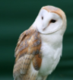
_____________________________________________________________
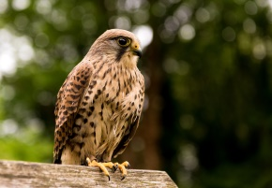
______________________________________________________________
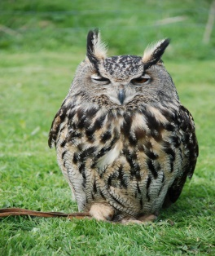
_____________________________________________________________
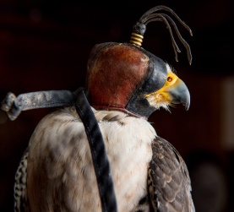
____________________________________________________________
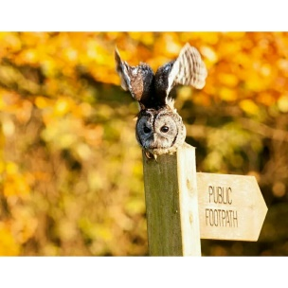
_____________________________________________________________

These are all birds of prey that live in England

WORK SHEETS - Continued

Choose a bird of prey and find out…….

1. What Species is it? _____________________________________________________
2. What does it like to eat? _________________________________________________
3. Which country is it from? ________________________________________________
4. What colour is it? ______________________________________________________
5. What colour are its eyes? ________________________________________________
6. Does is hunt during the day or at night? _____________________________________
7. Is it a big, medium or large bird? __________________________________________
8. What shape is its beak? __________________________________________________

Draw your bird here

BIRDS OF PREY HABITATS, ADAPTATIONS AND FOOD CHAINS

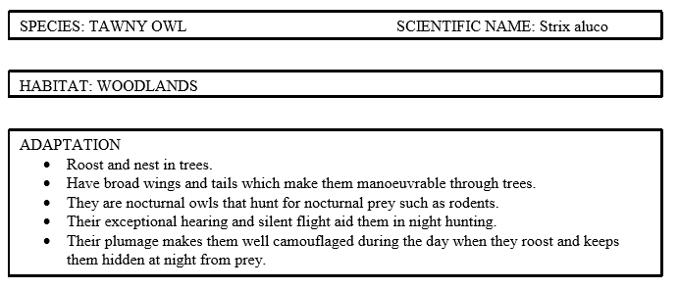

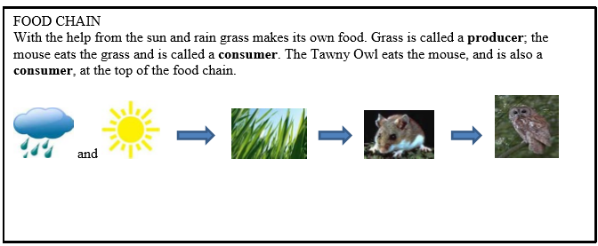

Choose another species at the centre and fill in the spaces below.

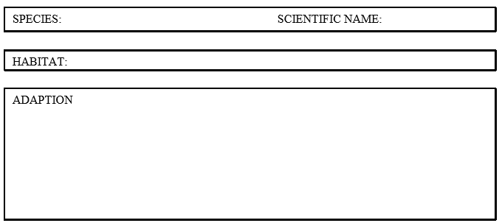

WORD SEARCH

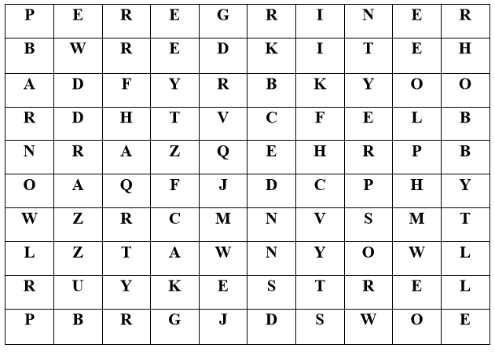

Find the following British birds in the word search:

Red Kite

Peregrine

Barn Owl

Tawny Owl
Buzzard

Hobby

Kestrel

Osprey

Name of School/Group:  Address: |  |  |  |  |  | Date of Visit:
Contact Name: |  |  |  |  |  | Contact Tel:
Email: |  |  | Invoice To:
Educational Packages
1 Hr Falconry Talk & Encounter £110 ☐
2 Hr Falconry Talk & Encounter £180 ☐
3 Hr Falconry Talk & Encounter £210 ☐
4 Hr Falconry Talk & Encounter £240 ☐
5 Hr Falconry Talk & Encounter £300 ☐
6 Hr Falconry Talk & Encounter £360 ☐

Full Day Including Talks, Encounters and Flying Display £450 ☐

Time of Arrival: |  |  |  | Time of Departure:
Number in Party: |  | Students: |  |  |  | Teachers:
Age Groups:

Subjects Studied:
Deposit:
Office Notes:

School Visit Booking Form

Walworth Birds of Prey, 4 West View, Hummerbeck, DL14 9PG
E-Mail: info@walworthbirdsofprey.com Tel: 07815 756 386
www.walworthbirdsofprey.com

